Peake Healing Massage

Massage Intake Form

Personal Information

Name: ___________________________________ Occupation: _________________________
Address: __________________________ City: _____________ State: _____ Zip: ___________
Daytime Phone: (_____) _________________ Evening Phone: (_____) __________________
Email Address: ______________________________________________ DOB: _____________
Employer: ___________________________________ Primary Physician: _________________
Emergency Contact: ____________________________ Phone: (_____) __________________

Massage Experience

How did you hear about us? _____________________________________________________
Have you ever had a professional massage before? Y / N
What type of pressure do you like? (Please Circle) Light----Medium----Firm----Deep
Are you comfortable with any of the following areas to be massaged?
Gluteal Region (Y/N) Pectoral Region (Y/N) Face/Scalp (Y/N) Feet (Y/N)

Health History
Please list any medications or supplements you are currently taking and explain: _____________________________

Please list any injuries/illnesses still affecting you: _____________________________

Circle any that apply to you:
- Cancer
- Headache
- Arthritis
- Diabetes
- Joint Replacement
- Blood Pressure High/Low
- Neuropathy
- Fibromyalgia
- Stroke
- Heart Attack
- Kidney Dysfunction
- Blood Clots
- Numbness
- Sprains/Strains

Please circle any area of discomfort
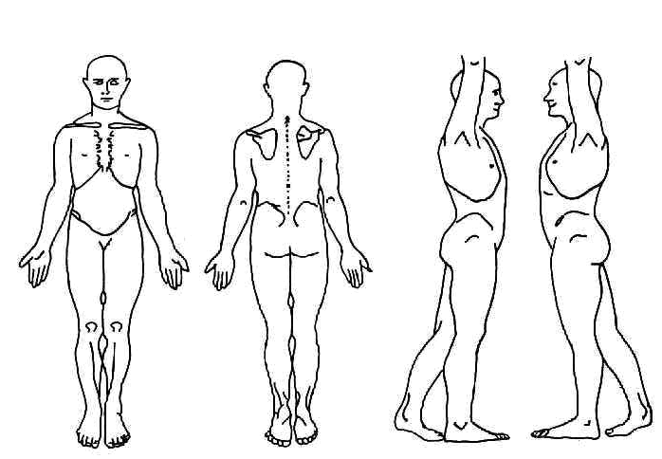

Peake Healing Massage

Release Form

By signing this, I agree that I have answered all questions to the best of my knowledge and that I will inform the therapist of any changes in my condition or medication. If I experience any pain/discomfort or would like the pressure adjusted, I will inform the therapist immediately.

I understand that a massage therapist cannot diagnosis any illness, disease, or any physical or mental disorders nor can the therapist prescribe any medication and that nothing said in a session should be construed as such. I understand that massage therapy is intended to work in conjunction with my health care, not act as a substitute for medical examination. I understand that it is my responsibility to consult a physician for any ailments I may have.

I understand that massage therapy is a therapeutic measure used to reduce stress, muscular tension, and pain. I understand there are no guarantees for recovery and if I am unsatisfied with the progress made with my treatment, I will inform the therapist, so he/she may direct me to another treatment. I also understand that massage therapy is non-sexual in nature and any advancement made will terminate the massage.

I agree to abide by a 24-hour cancellation notice for any scheduled massage. I understand I may be charged up to the full amount of service for missed appointments or for any cancellations with less than a 24-hour notice. I understand that if I arrive late for an appointment, the session will end at the original scheduled time to prevent penalizing another client. However, if the massage therapist is late, he/she will fulfill the scheduled massage length or offer a reasonable compensation.

I understand that if I use a coupon during my visit, it is not valid with any other coupons or promotions.

I agree that I am of legal age (18 years old) and that if I am not, I agree to have my parent or guardian sign a parental/guardian release form before treatment.

I understand that certain conditions or medications may contraindicate (not permit) massage or may require the use of alternate techniques or pressure. I respect the decision of the massage therapist and am fully prepared to reschedule the massage for a later date if requested by the massage therapist. I also understand that massage may be advisable by my physician, but not by a massage therapist. In that event, I agree to provide a written agreement from my physician before proceeding with treatment.

Print Name: ___________________________________________

Signature: _________________________________________Date: ______________________

